

**PAMANTASAN NG LUNGSOD NG MAYNILA**

College of Information Systems and Technology Management (CISTM)

**ICC 0104-1 – Data Structures and Algorithms**

*A.Y. 2023- 2024*

**Group 4**: Searching

**Submitted by**:

Abundo, Jonalene Ryza B.

Dela Peña, Daniella Mae N.

Diamzon, Momer Ailes M.

Lau, Trisha Mae R.

Mahusay, Lindsay G.

Matanga, Sophia Vien V.

Rivera, Ramyll C.

Sibayan, Joan F.

BSCS 1-1

1. Main Menu

Source Code in C++

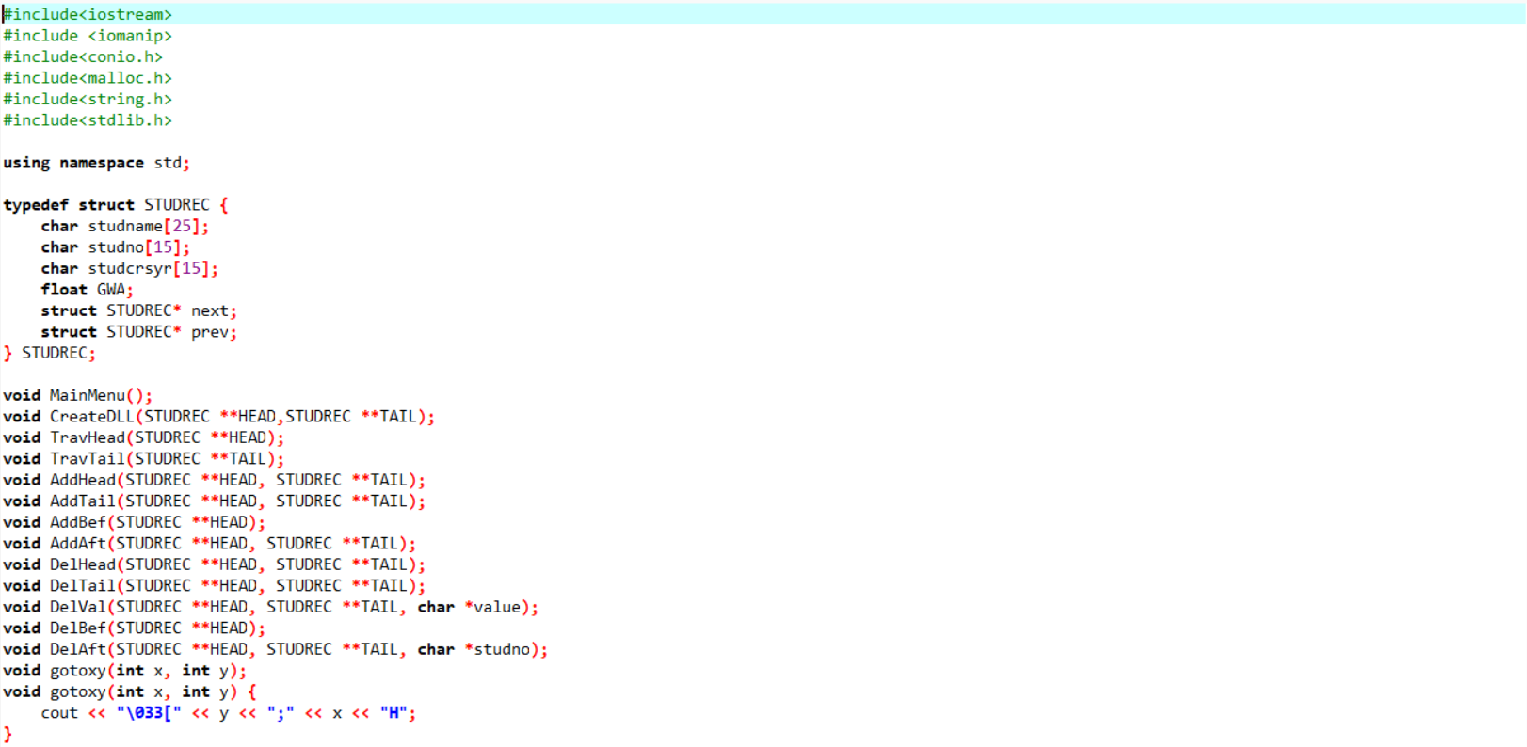

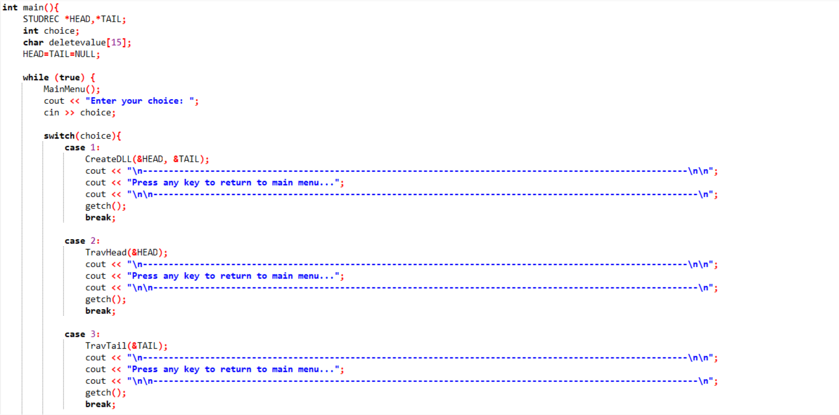

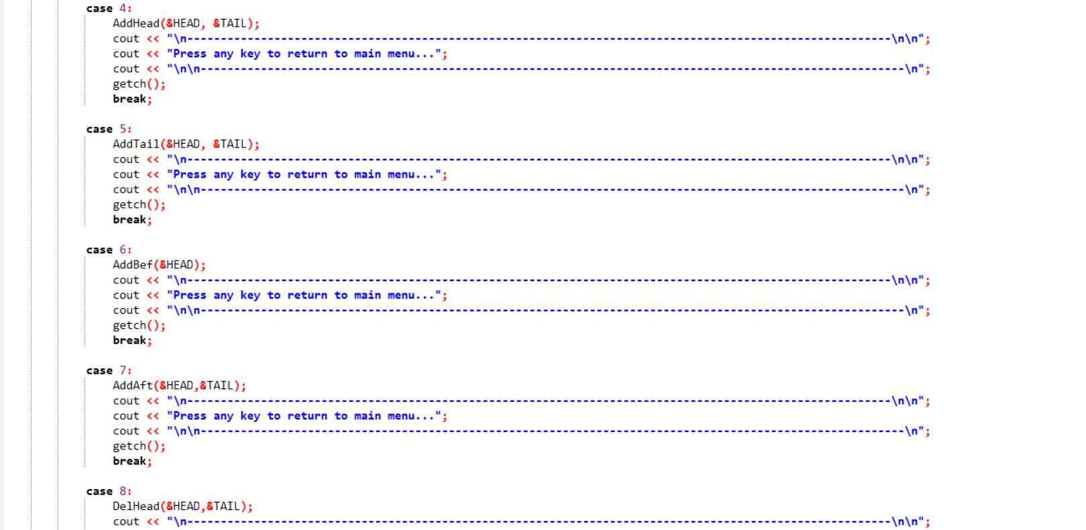

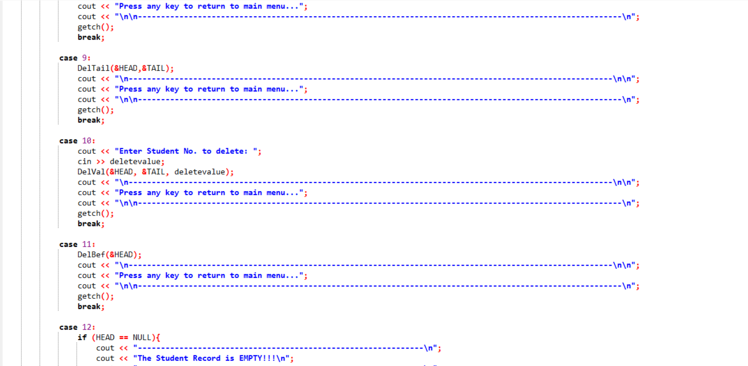

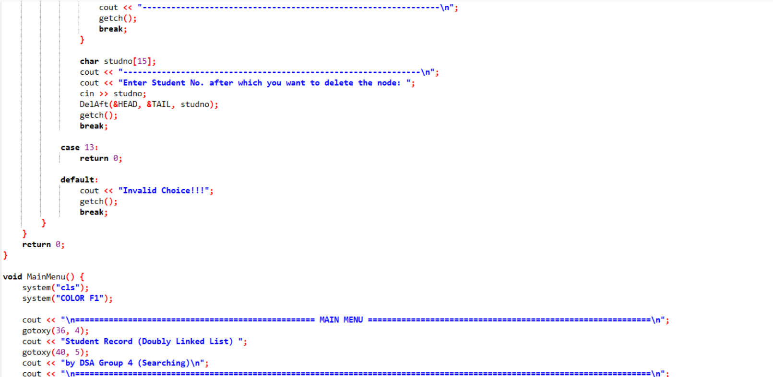

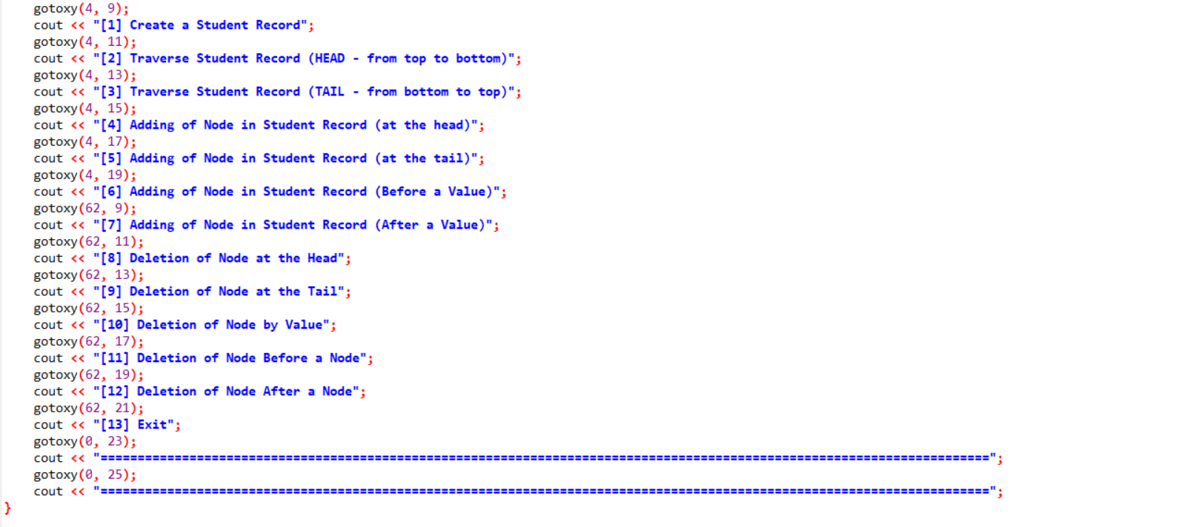

Output

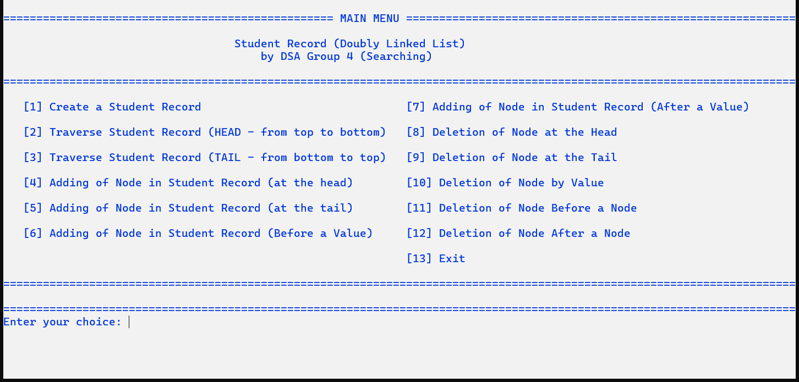

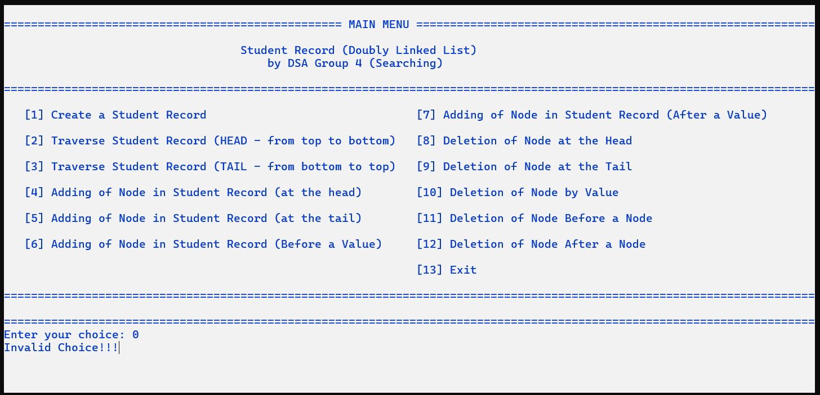

*(Figure 1: Main Menu – Functions)*

1. Creation of Double/Doubly Linked List

Source Code in C++

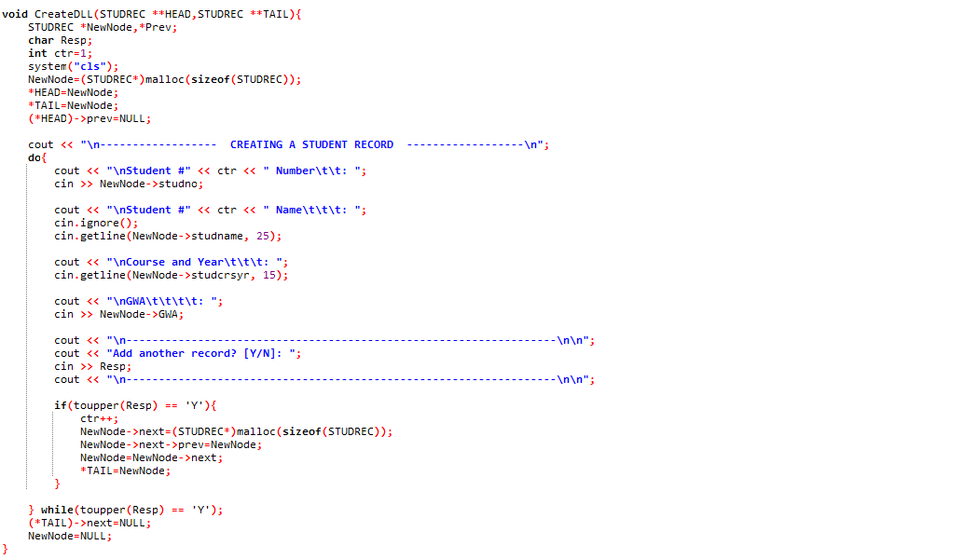

Output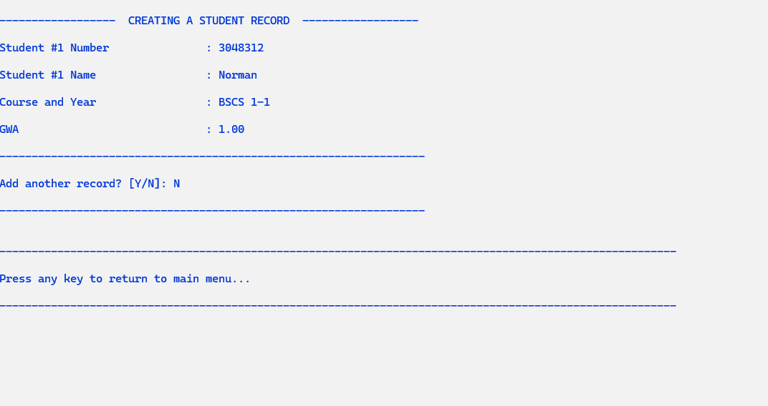

*(Figure 2: Main Menu– Selecting “Create a Student Record” Option)*

1. Traversal of Double/Doubly Linked List (Head - Top to Bottom)

Source Code in C++

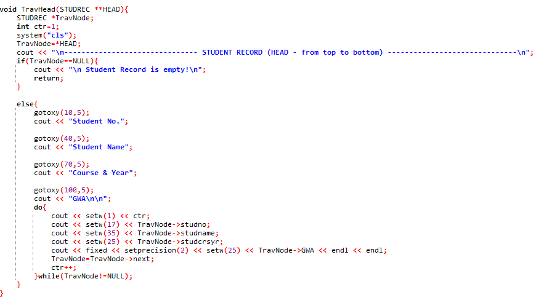

Output

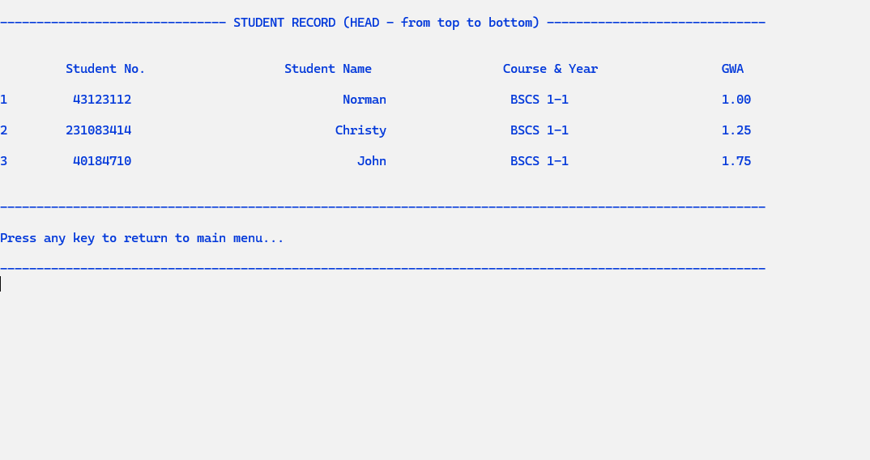

*(Figure 3: Displaying the Student’s GWA Report in Tabulated Format)*

1. Traversal of Double/Doubly Linked List (Tail - Bottom to Top)

Source Code in C++

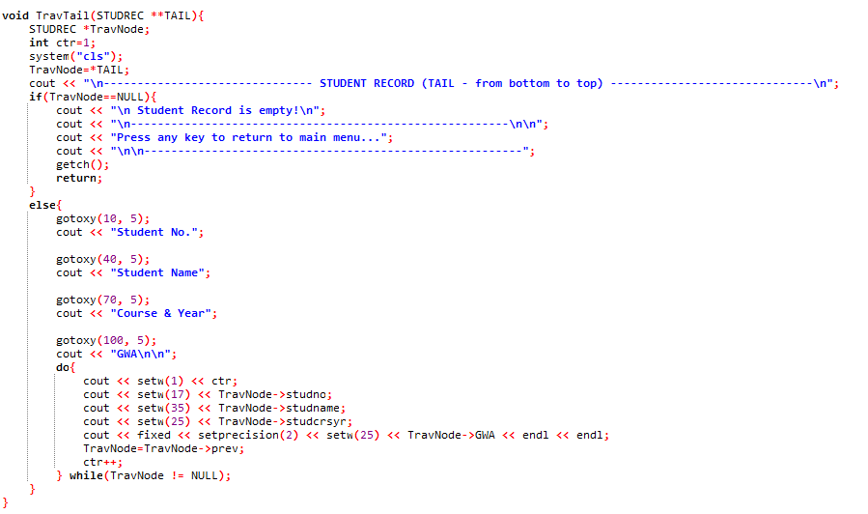

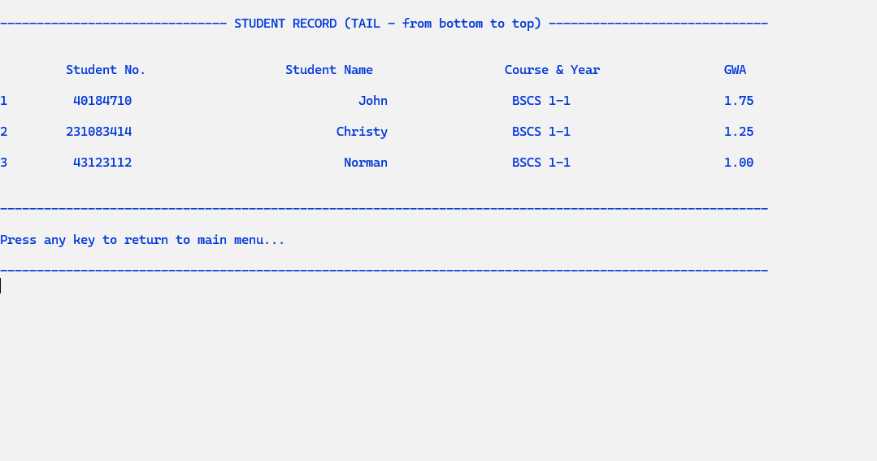Output

*(Figure 4: Displaying the Student’s GWA Report in Tabulated Format)*

1. Adding/Insertion of Node in Double/Doubly Linked List (at the Head)

Source Code in C++

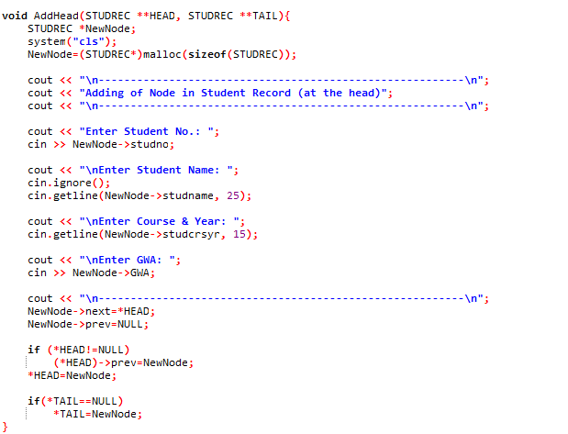

Output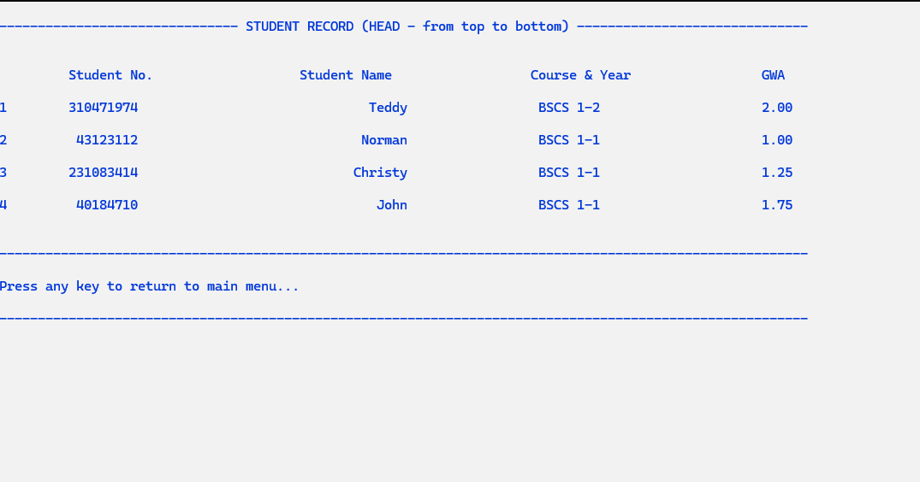

*(Figure 5: Displaying the New Student Record Added at the Start of the Node)*

1. Adding/Insertion of Node in Double/Doubly Linked List (at the Tail)

Source Code in C++

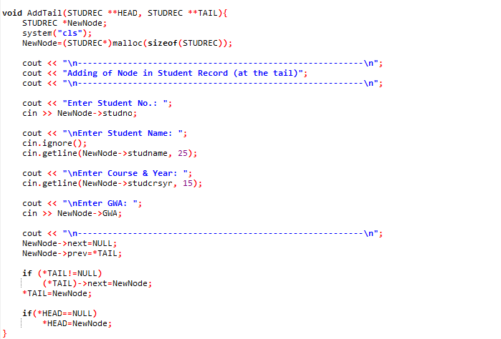

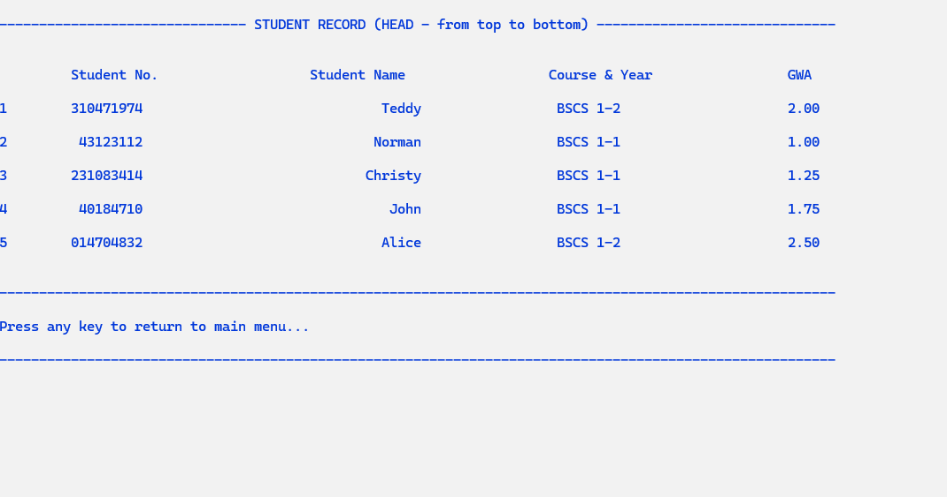Output

*(Figure 6: Displaying the New Student Record Added at the End of the Node)*

1. Adding/Insertion of Node in Double/Doubly Linked List (Before a Value/Data)

Source Code in C++

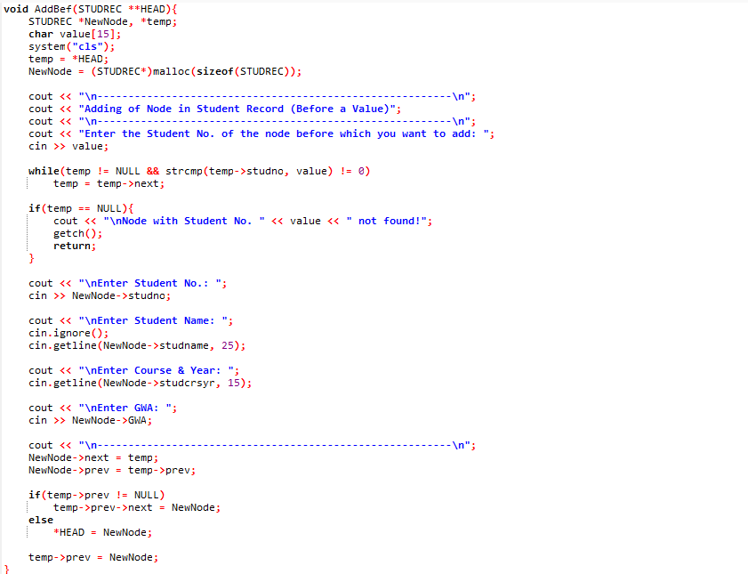

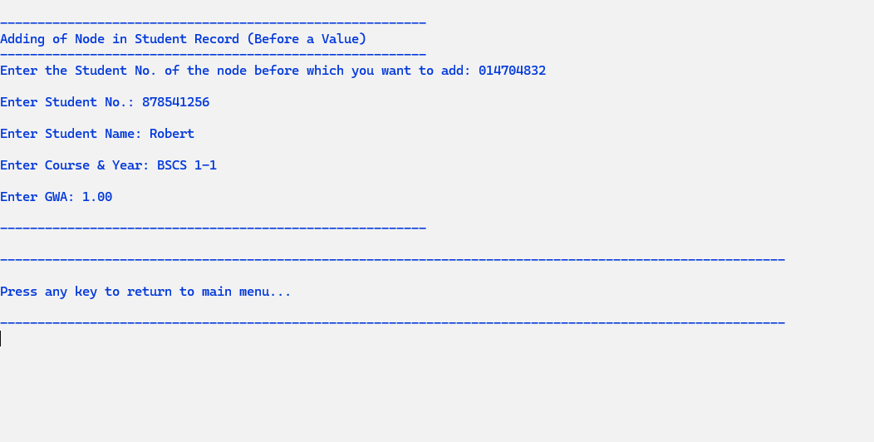Output

*(Figure 7: Inserting a New Record Before the Specified Node Operation)*

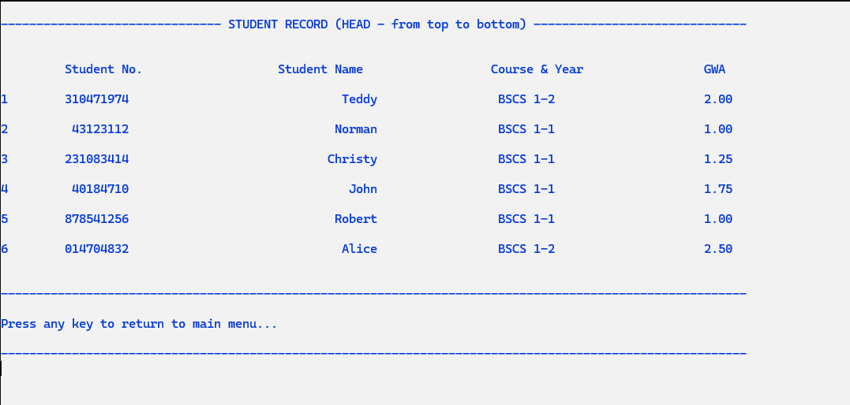

*(Figure 7.1: Displaying the New Student Record Added Before the Specified Node)*

1. Adding/Insertion of Node in Double/Doubly Linked List (After a Value/Data)

Source Code in C++

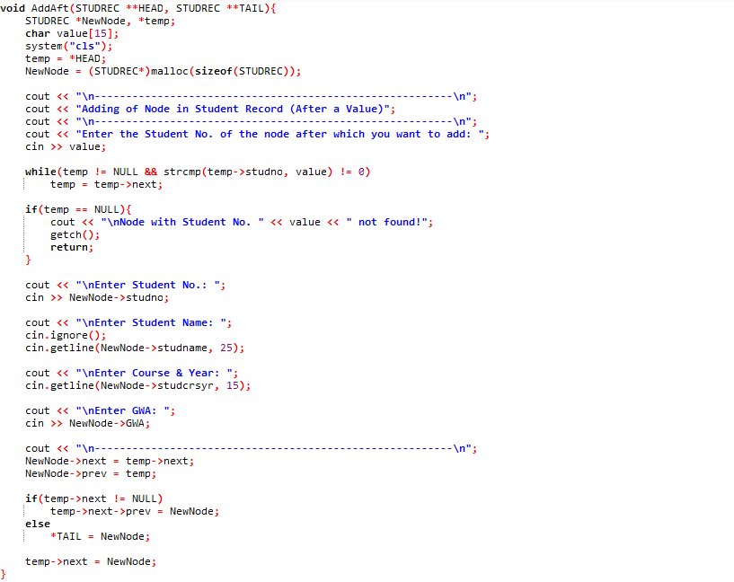

Output

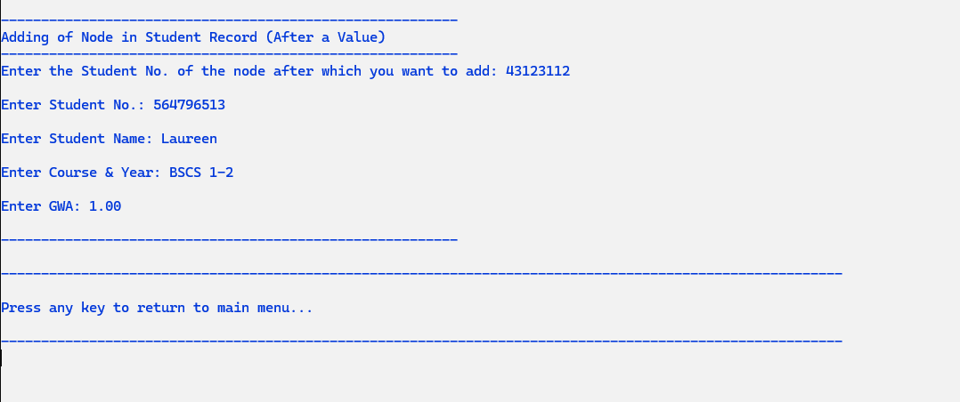

*(Figure 8: Inserting a New Record After the Specified Node Operation)*

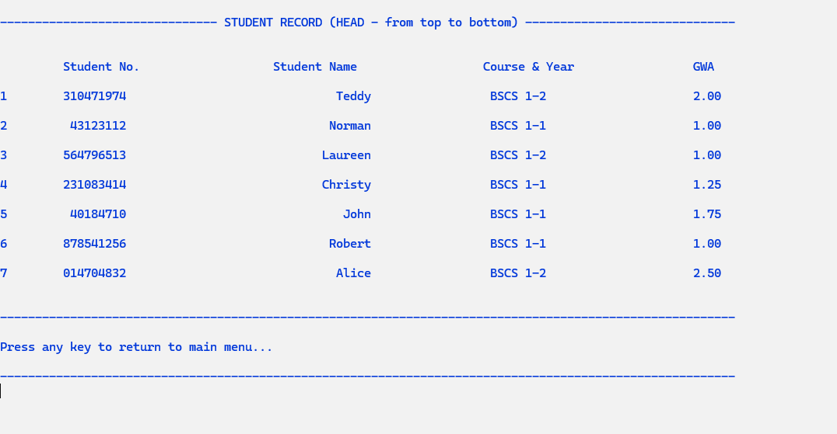

*(Figure 8.1: Displaying the Student’s GWA Report in Tabulated Format)*

1. Deletion of Node in Double/Doubly Linked List (at the Head)

Source Code in C++

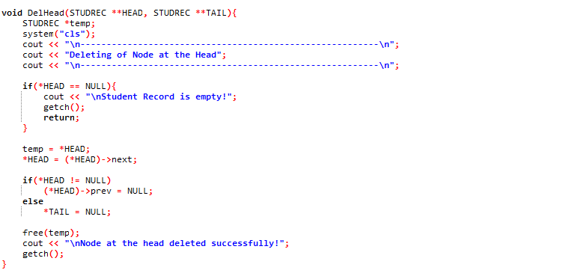

Output

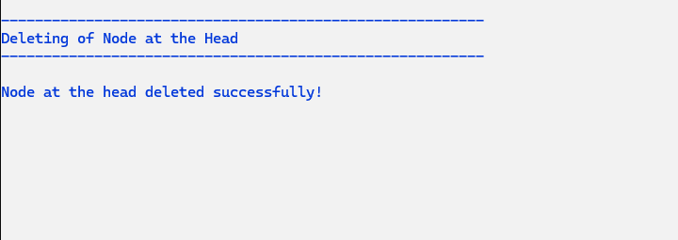

*(Figure 9: “Deletion of Node at the Start” Option)*

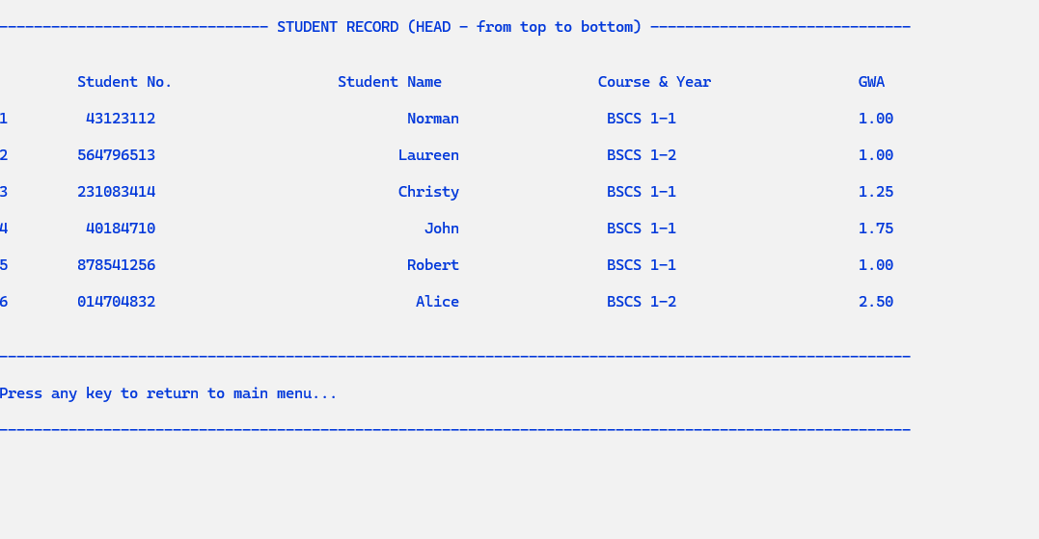

*(Figure 9.1: Displaying the New Student Record Added After Deleting the Node at the Start)*

1. Deletion of Node in Double/Doubly Linked List (at the Tail)

Source Code in C++

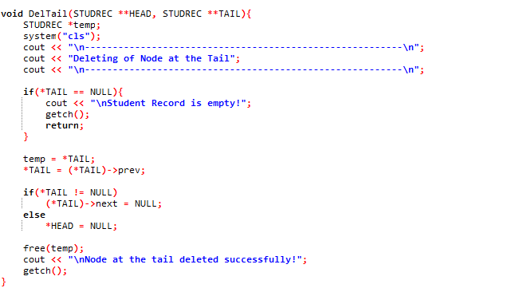

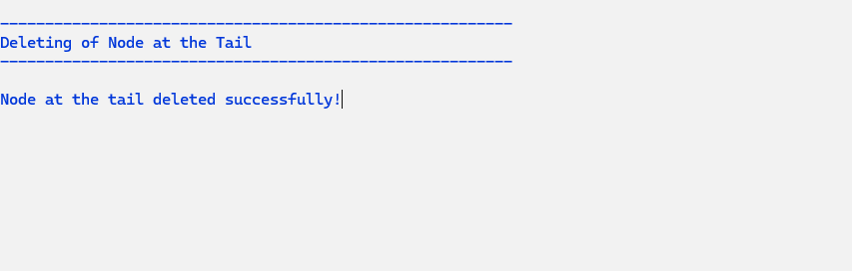Output

*(Figure 10: “Deletion of Node at the End” Option)*

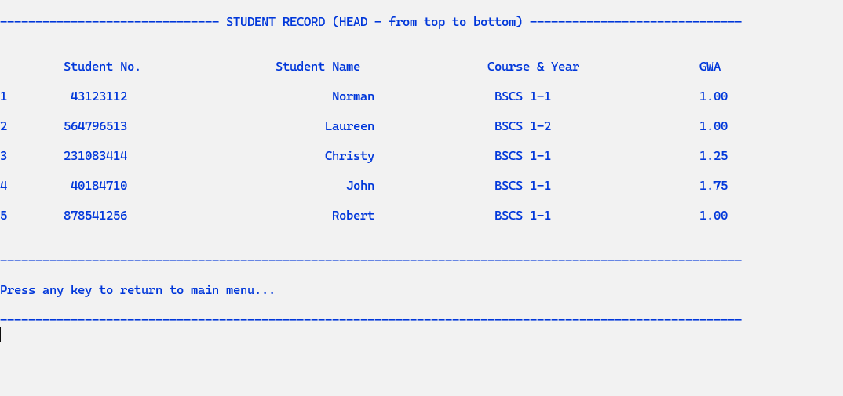

*(Figure 10.1: Displaying the New Student Record Added After Deleting the Node at the End)*

1. Deletion of Node in Double/Doubly Linked List (by Value)

Source Code in C++

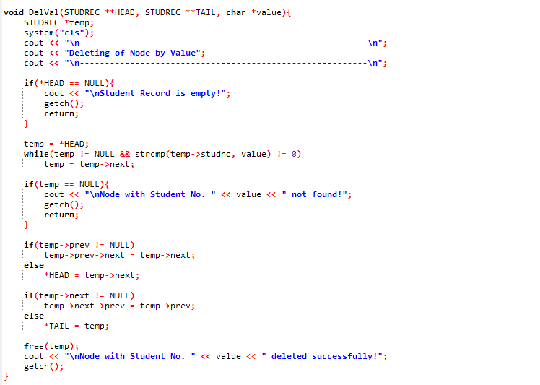

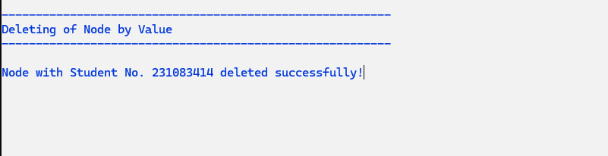Output

*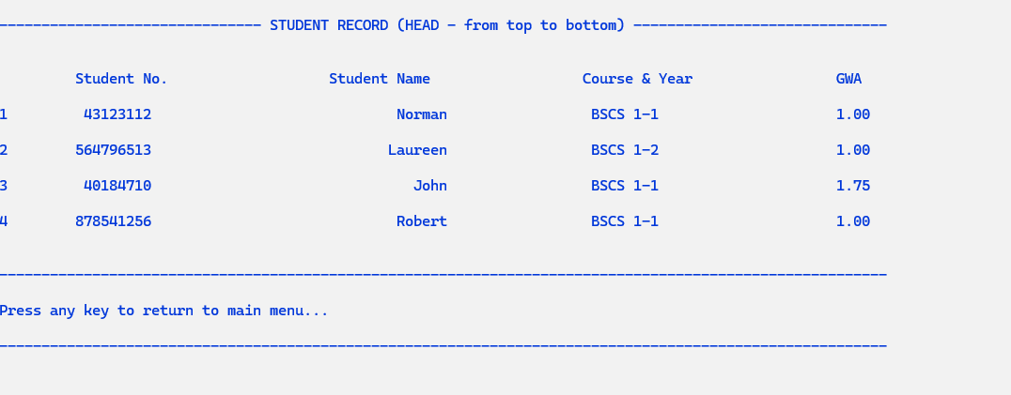(Figure 11: “Deletion of Node by Value” Option)*

*(Figure 11.1: Displaying the New Student Record Added After Deleting the Node by Value)*

1. Deletion of Node in Double/Doubly Linked List (Before a Node)

Source Code in C++

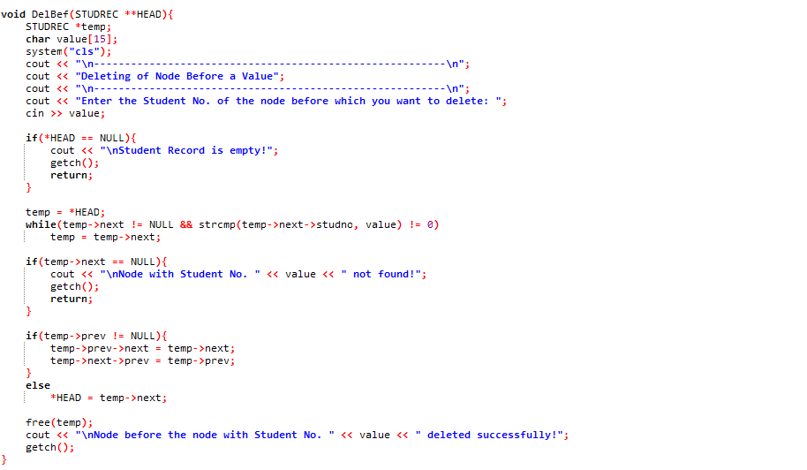

Output

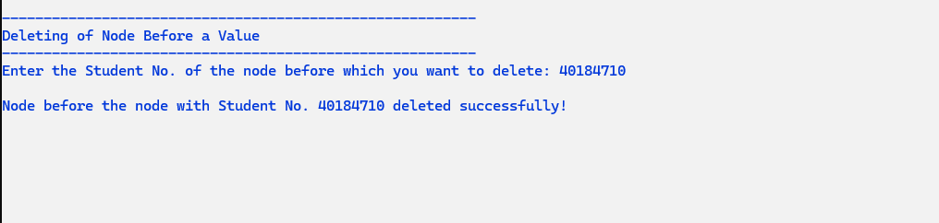

*(Figure 12: “Deletion of Node Before a Node” Option)*

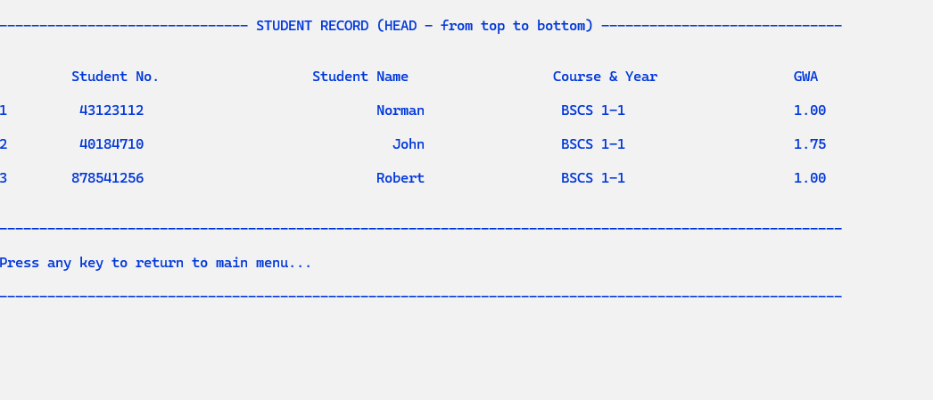

*(Figure 12.1: Displaying the New Student Record Added After Deleting the Node Before a Node)*

XII. Deletion of Node in Double/Doubly Linked List (After a Node)

Source Code in C++

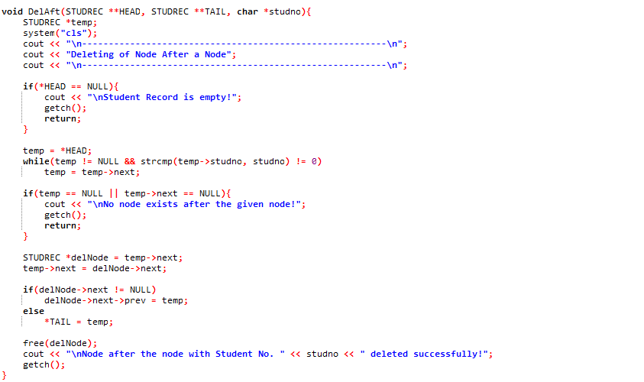

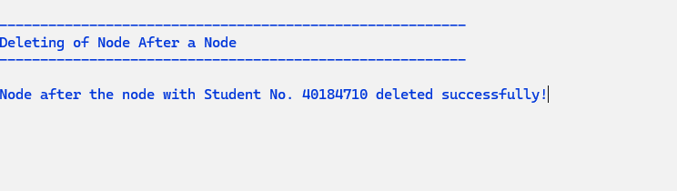Output

*(Figure 13: “Deletion of Node After a Node” Option)*

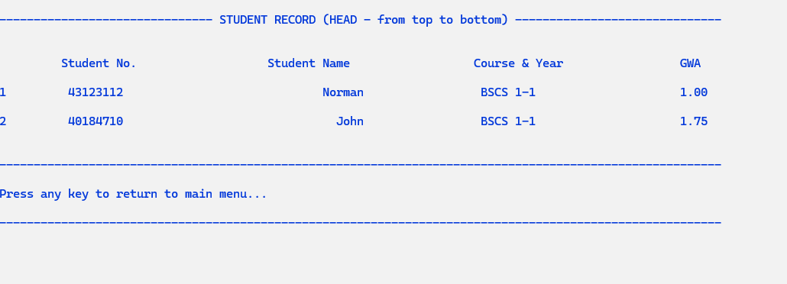

*(Figure 13.1: Displaying the New Student Record Added After Deleting the Node After a Node)*